Mini Search Engine

A PROJECT REPORT
Submitted by

Sr. no. | Name | Registration no.
1. | Nikhil | 12407032

in partial fulfillment for the award of the degree of
BACHELOR OF TECHNOLOGY

School of Computer Science and Engineering


Lovely Professional University, Punjab
July 2026

TABLE OF CONTENTS

Sr No | Topic | Page
1 | Abstract | 3 - 4
2 | Introduction | 5 - 6
3 | Problem Statement | 7
4 | Objectives | 8 - 9
5 | Scope | 10
6 | System design & analysis | 11
7 | Technologies Used | 12 - 13
8 | Architect Diagram | 14
9 | Module Description | 15
10 | Implementation | 16
11 | Code Snippets | 17 - 18
12 | Testing | 19
13 | Result | 20
14 | Output Screenshot | 21 - 23
15 | Conclusion | 24
16 | Future work | 25
17 | References | 26

ABSTRACT
The information now exists in digital media in a tremendous amount, making it a critical need to have efficient and reliable information retrieval systems. Typically, users need to browse through several documents to locate the information they are looking for, which is time consuming, inefficient and prone errors. In order to overcome this problem, the project has taken up the development of an advanced file-based search engine called Smart Search Engine Pro Using Java that will enable effective retrieval of the text documents from a set of text documents which will be fast, accurate and intelligent. The system is designed in java programming language and includes basic concepts of Object Oriented Programming, Data Structures, File handling and Information retrieval for a powerful and user friendly solution to searching. The proposed system uses Inverted Index technique in which all the documents of the text are preprocessed and indexed prior to any search operation. This indexing mechanism saves a considerable amount of time in the search process, as it maps directly the keywords in the documents in which they occur. The search engine features several advanced search capabilities: a single keyword search mode, multi-keyword search (AND/OR), word frequency analysis, a ranked search result list, a document statistics report, a search history management, and intelligent keyword suggestions for enhanced usability. The ranking mechanism is based on the number of times the keywords appear in documents, making it easy and efficient for users to find the most relevant documents. The application is designed to be modular and maintainable by using independent modules like Index Manager, Search Engine, Console User Interface, Search History, File Information Manager, Ranking Engine and Suggestion Engine. The Java Collection Framework classes, such as HashMap, ArrayList, Set, Queue, and TreeMap, are used extensively for their various uses in optimization of indexing, searching, and data management processes. The system is lightweight, platform-independent and easily extensible, suitable for small-scale enterprise applications, document management systems, digital libraries and educational purposes. In general, Smart Search Engine Pro offers a valuable insight into the architecture of modern search engines and the importance of optimizing algorithms and data structures for efficient information retrieval, making it a worthwhile resource for anyone interested in the field.

INTRODUCTION
Today, there is an abundance of electronic information which has changed how people, companies, and schools store and handle data. Thousands of text documents, reports, research papers, manuals and digital records are generated and saved daily on computers. With the growing amount of data, it has become difficult and time-consuming to find information within a huge number of files. Users are forced to open numerous files and manually search them for relevant information, which is hugely time consuming and can result in important information being missed. This has motivated the need for intelligent information retrieval systems that are able to retrieve relevant and information in a timely, accurate and efficient manner.
One of the most significant applications in the area of Information Retrieval (IR) is a search engine. The main goal is to organize, index and retrieve information according to the query of the user, with a minimum amount of time for search and a maximum amount of accuracy in the results. Today's search engines use sophisticated indexing methods, ranking algorithms, and fast data structures to handle millions of search queries in a matter of seconds. While commercial web search engines like Google and Bing work on a massive scale, a local document search engine provides a good way to illustrate the basic concepts behind the operation of a web search engine. The project is about applying these core concepts in a simple but efficient way with the java programming language.
Smart Search Engine Pro Using Java is a file-based information retrieval system that can index several text documents in a local folder. The system first scans all documents to build an Inverted Index, which is a very efficient data structure that maps each unique keyword to the documents containing the keyword. The solution to this problem is a preprocessing solution that removes the necessity of scanning all the documents each time a request comes in to search it, which significantly increases the speed of the search and decreases the execution time.
The app has some sophisticated features other than just keyword search to improve user experience. These are features such as single keyword search, multi keyword (AND/OR) search, document ranking by keyword frequency, word frequency analysis, search history management, file statistics and the intelligent keyword suggestion mechanism. The system has been designed with Object Oriented Programming (OOP) concepts which lead to modularity, scalability, code reusability and ease of maintainability. The Java Collection Framework includes classes like HashMap, ArrayList, TreeMap, Set and Queue that are used to efficiently store and retrieve indexed data, with optimized retrieval operations.
It is a project that not only shows how to implement the data structures and algorithms but also gives insight into the design and development of search engines, indexing techniques and efficient information retrieval systems. The resulting app is an ideal learning tool to learn the inner workings of the search engine, and a very useful tool to manage digital notes, academic papers, technical manuals, and any other kind of text-based repository. Its modular design also facilitates future improvements, including the use of graphical user interfaces, PDF indexing, database integration, cloud synchronization, semantic search, and artificial intelligence–based query processing, making it an excellent platform for developing more sophisticated information retrieval applications.

PROBLEM STATEMENT
With the growing number of document-based information, the retrieval of information has become a challenging task for people, educational institutions and organizations. Users are forced to spend more time searching through multiple documents by hand to find the information that is needed, and it also tends to slow down the user's productivity and lessen the likelihood of finding relevant information. These are time-consuming and inefficient methods when you have a lot of documents and you're looking for more than one word, or you're trying to find the most relevant one among a large number of similar documents.
Most basic file search tools use name-based searching or a text-based approach to searching, and do not support intelligent search capabilities like document ranking, keyword frequency analysis, multi-keyword searching, or searching suggestions. They also repeatedly scan files on each search query, which compromises the performance and scalability. In addition, there is no efficient indexing mechanism, which can have a negative effect on the response time and on the effectiveness of the search process.
The main aim of this project is to develop a local document search engine that would retrieve relevant information from a set of text files with minimal execution time, fast, accurate and efficient. The system that is proposed uses an Inverted Index to preprocess and organize the contents of the documents so that retrieval of the document by a keyword becomes a fast operation without having to repetitively scan the files. Moreover, the system organically introduces some modern ideas of information retrieval and software engineering concepts, such as single-keyword search, multi-keyword (AND/OR) search, frequency-based ranking, management of search history and intelligent suggestions of keywords, which are essential to enhance search efficiency, improve user experience and show practical applications of the information retrieval

OBJECTIVES
The main objectives of this Smart Search Engine Pro Using Java project is to design and code an efficient, reliable and user friendly information retrieval system that can search from large collections of text documents efficiently and accurately. The proposed project specifics are:
- Create an efficient document search engine : Design an efficient document search engine. Create and develop a java based search engine which allows the user to search the relevant information from a number of text files within a few seconds with efficiency rather than opening each file.
- To implement an Inverted Index : To build an optimized Inverted Index to store the association between keywords and documents, thus optimizing the search time and performance of retrieval.
- Create a Single Keyword Search option : To give the user the ability to search documents with a single Word and get back all the files that contain the desired word.
- Support Multi-Keyword Search : To enable multiple keywords search with AND and OR priority to provide more precise and flexible search.
- Rank Search Results : To be able to priorities search results according to how important and relevant they are to the documents and therefore rank them at the top of the search results list, improving user experience.
- How to carry out Word Frequency Analysis : To find and show the frequency distribution of each keyword appearing in the documents being indexed, so that a user can learn about the distribution of each keyword and the relevance of the documents.
- Maintain Search History : To store searches already performed and make them available to users to view the history, allowing them to review their past searches, improve accessibility and analyze their search patterns while using the application
- Generate Intelligent Keyword Suggestions : To add a suggestion feature that suggests alternative keywords or alternative spellings of the query word if a wrong or misspelled word is typed in.
- Use efficient data structures : To use advanced classes of the Java Collection Framework to efficiently store, index and retrieve information from documents (HashMap, ArrayList, Set, Queue, TreeMap).
- Use Object-Oriented Programming Principles : To design and build an application that uses modular and re-usable Object-Oriented Programming concepts; encapsulation, abstraction, inheritance (where appropriate) and polymorphism to ensure better maintainability and scalability.
- Improve Search Performance : To preprocess and index files for quick retrieval in the future for the purpose of files to be searched, thereby avoiding a redundant scanning of files and increasing overall system efficiency.
- Develop a scalable and extensible system : To develop a flexible software architecture that can be easily extended in the future with new advanced features like graphical user interface, PDF document indexing, database integration, semantic search, cloud storage support, and artificial intelligence–based query processing, while keeping the existing system unchanged.

SCOPE

The aim of the project is to create a desktop based efficient and reliable information retrieval system that can search and manage multiple text documents residing in a local file system using the Smart Search Engine Pro Using Java. This application provides fast, accurate and organized search results due to the use of an Inverted Index to decrease the search time compared to traditional sequential file searching methods. The system provides the functionalities that are essential for any search engine, such as: Single-keyword search, Multi keyword (AND/OR) search, Frequency based ranking, Document statistics, Search history management and Intelligent keyword suggestions, which improves search experience. The project is a good practical implementation of Object Oriented Programming, Java File Handling concepts, Data Structures, Algorithms and Information Retrieval. It offers flexibility and long-term usability due to its modular design, which enables easy replacement, upgrade, and expansion of individual parts. It is an ideal choice for educational institutions, digital libraries, document management systems in personal offices, digital research repositories and small organizations wishing to search efficiently within locally stored text files. Additionally, the developed system serves as a solid basis for further improvements, such as integration with Graphical User Interfaces (GUIs), indexing of PDF and Word documents, database connections, support for cloud-based storage, semantic search, natural language processing, and Artificial Intelligence–based search recommendations. This allows for scalability, extensibility, and applicability to current information retrieval needs and provides an illustration of good software engineering practices.

SYSTEM DESIGN & ANALYSIS
The System Design and Analysis is a significant phase that helps in making efficient, reliable and user-friendly Smart Search Engine Pro Using Java. The main task of the analysis phase was to understand the problems with traditional file searching techniques and find the functional and technical needs to build a fast information retrieval system. The analysis led to the identification of certain requirements for a solution that would be able to index documents fast, return the correct keywords when searching, rank search results by relevance, and be intuitive to use, but not have high computational cost. To meet the requirements, the system was designed according to the modular Object-Oriented Architecture, in which each module has a specific responsibility and can interact with other modules without problems. The application comprises of standalone modules like File Scanner, Index Manager, Search Engine, Ranking Engine, Suggestion Engine, Search History and Console User Interface. The modular design promotes maintainability, scalability, and code reusability, enabling future enhancements to be incorporated into the system with minimal changes. The system uses an Inverted Index as its main data structure, which enhances the speed of searching. All text documents are preprocessed (scanned, tokenized, cleaned, indexed) beforehand, so that when the application requests a matching document it doesn't have to scan a specific file again for the search query. The Java Collection Framework classes are used to handle efficient storage, indexing, ranking, and history management – these include HashMap, ArrayList, Set, and Queue. In summary, the design of the system focuses on high performance, modularity, scalability, and efficient information retrieval, ensuring that the application provides quick and accurate information retrieval and offers a solid basis for future improvements, including the integration of graphical user interfaces, cloud integration, semantic search, and Artificial Intelligence–based recommendation techniques.

TECHNOLOGIES USED

'Smart Search Engine Pro' is built using Java, leveraging modern software development technologies and Java programming concepts to create a fast, reliable, and efficient information retrieval system. Each technology plays a specific role in the application ranging from processing text documents to indexing, searching, and displaying ranked search results. This combination of technologies ensures high performance, modularity, scalability, and ease of maintenance, while also providing the user with a seamless and intuitive experience.

Technology | Purpose
- Java (JDK 17/21) | Primary programming language used to develop the entire search engine application with platform-independent execution and robust object-oriented features
- Object-Oriented Programming (OOP) | Provides modular architecture through classes, objects, encapsulation, abstraction, and code reusability, making the system scalable and maintainable.
3. Java Collections Framework | Utilizes HashMap, ArrayList, Set, Queue, and TreeMap for efficient indexing, searching, ranking, and management of document information.
4. File Handling (Java IO) | Reads, scans, and processes text documents stored in the local file system for indexing and keyword extraction.
5. Inverted Index Algorithm | Organizes keywords with their corresponding documents, enabling rapid and efficient information retrieval without repeatedly scanning files.
6. Ranking Engine | Calculates document relevance using keyword frequency, ensuring the most relevant search results are displayed first.

By leveraging these technologies in combination, Smart Search Engine Pro offers features such as rapid document indexing, precise keyword searching, improved result ranking, smart suggestions, and a modular software architecture. This makes it suitable for educational projects, document management systems, digital libraries, and small-scale information retrieval applications..

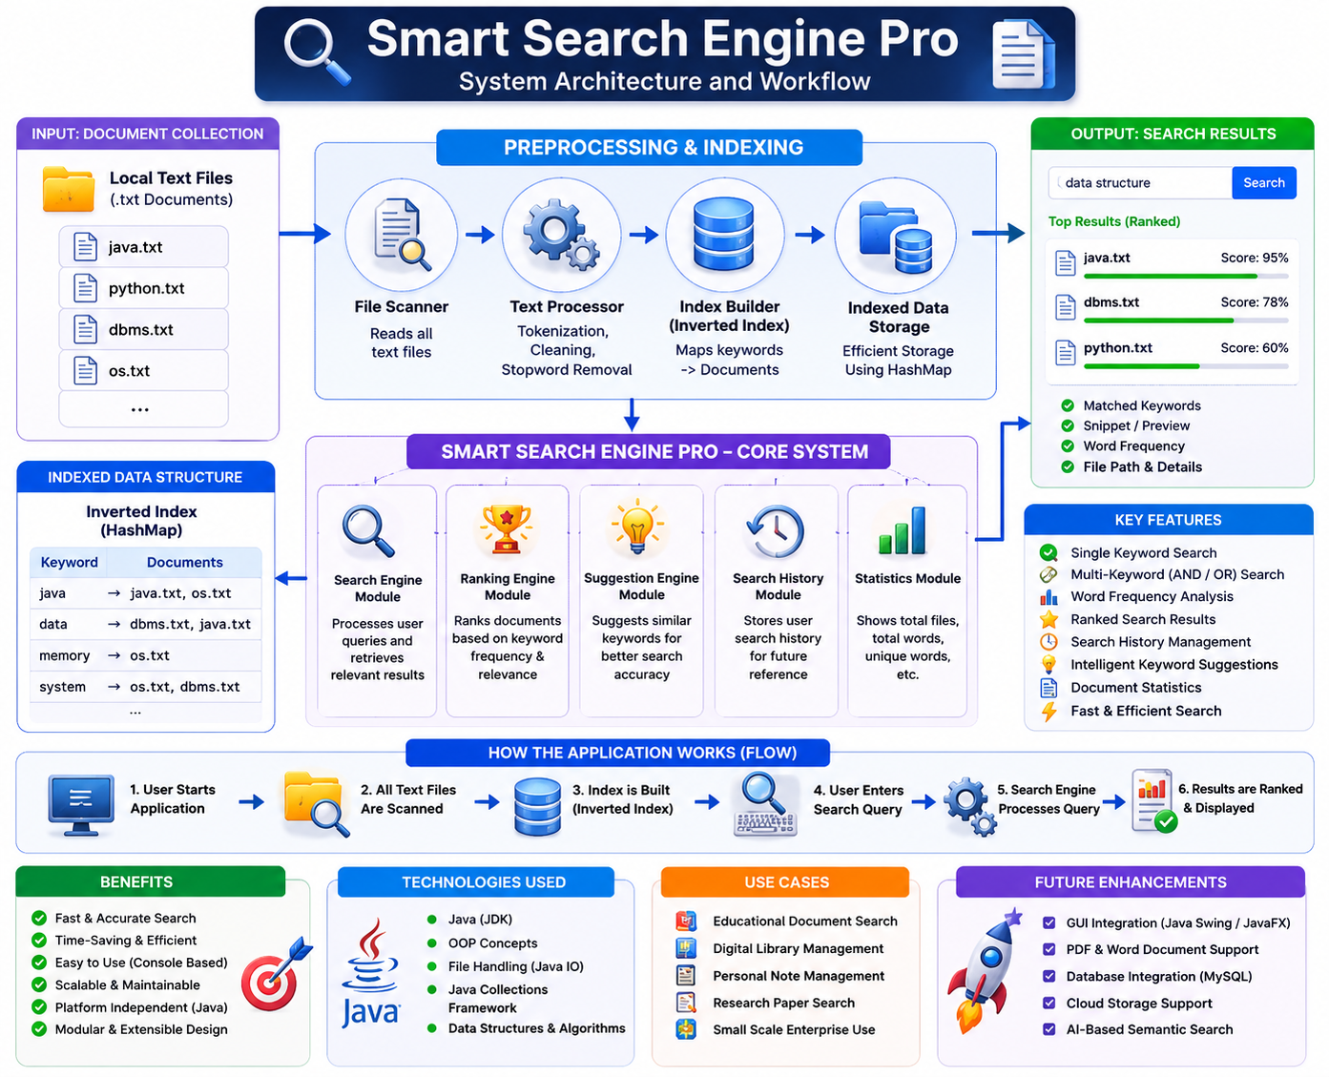
ARCHITECT DIAGRAM



MODULE DESCRIPTION

The Smart Search Engine Pro Using Java consists of the following major modules:
- File Scanner Module: Reads all text documents from the specified directory, scans their contents, and extracts the textual data required for indexing and search operations.
- Index Manager Module: Creates and maintains an efficient Inverted Index by mapping keywords to their corresponding documents, enabling fast and optimized information retrieval.
- Search Engine Module: Processes user search queries, performs single-keyword as well as multi-keyword (AND/OR) searches, and retrieves the most relevant documents from the indexed data.
- Ranking Engine Module: Calculates the relevance score of each document based on keyword frequency and ranking algorithms, ensuring that the most relevant search results are displayed first.
- Suggestion Engine Module: Provides intelligent keyword suggestions for misspelled or partially entered search queries, improving search accuracy and enhancing the overall user experience.
- Search History Module: Maintains a record of previously searched keywords and queries, allowing users to review their search history and improve search efficiency.
- Console User Interface (Console UI) Module: Provides a user-friendly, menu-driven command-line interface through which users can perform searches, view statistics, access search history, and interact with all system functionalities efficiently.

IMPLEMENTATION
The implementation of the Smart Search Engine Pro Using Java is done in a modular and object-oriented manner to achieve efficiency, maintainability and scalability. The system first lists all the text documents in a given folder, and preprocesses the text contained in these documents by tokenizing and cleaning the extracted text. The Java Collection framework is then used to build an Inverted Index for fast retrieval of keywords. When a user enters a query, the Search Engine analyzes it, fetches the relevant documents from the indexed data and ranks the documents according to the number of occurrences of the keywords. Several other modules offer intelligent keywords suggestions, keep an historical search and show the statistics of the documents in an easy to use console interface, resulting in a quick and efficient information-retrieval-process.

CODE SNIPPETS
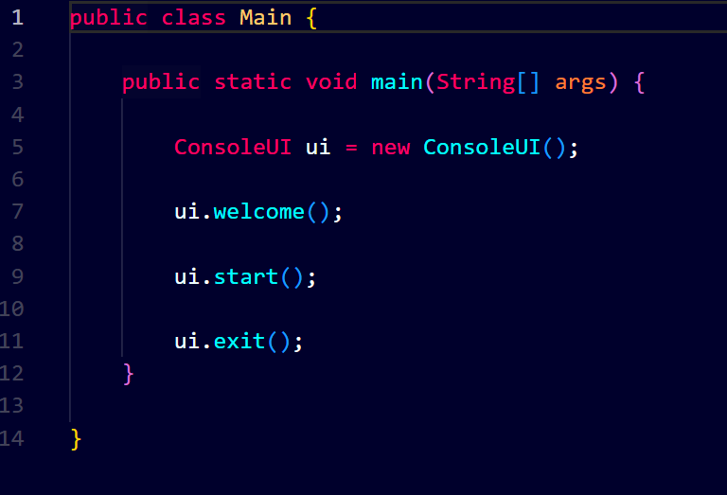

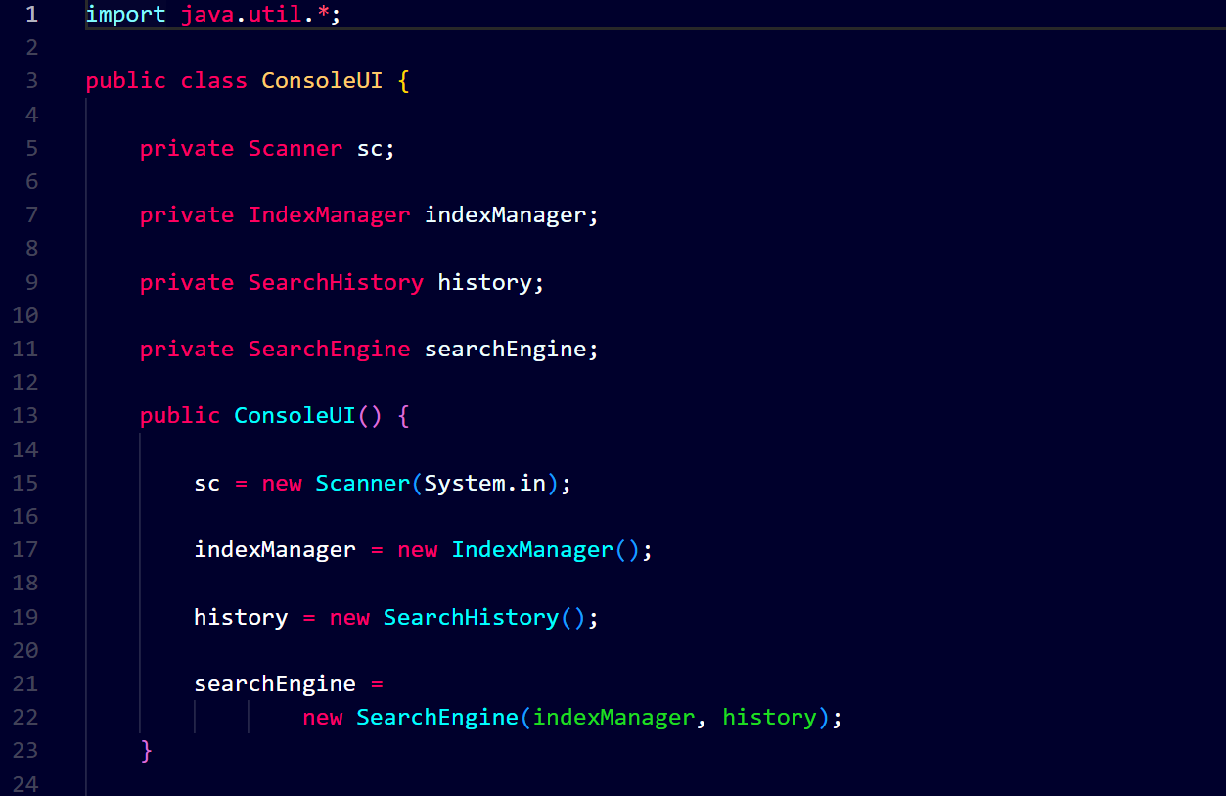
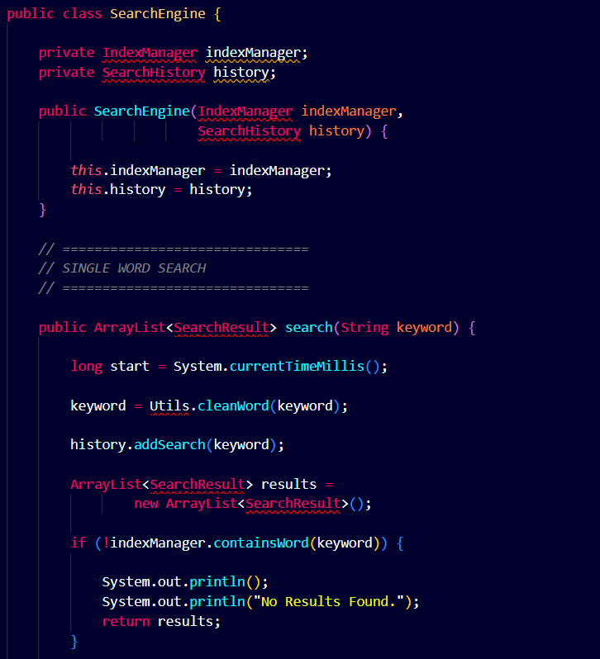

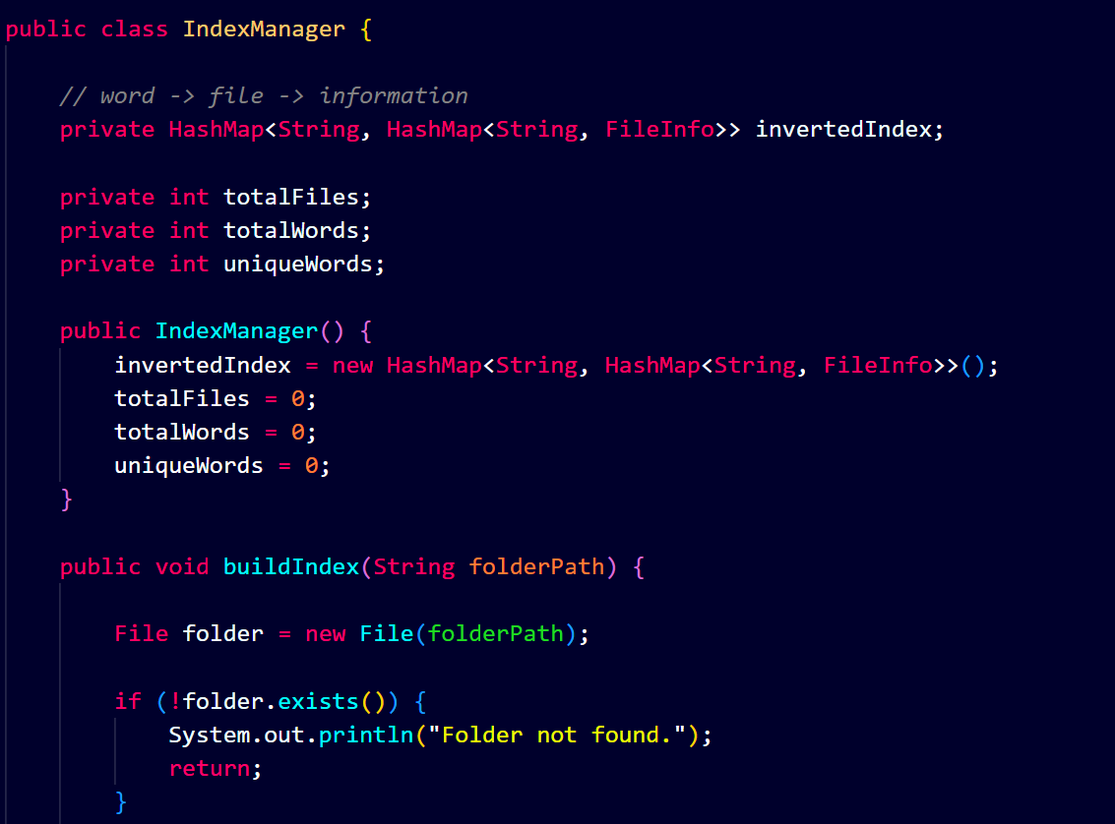

TESTING

The functionality, efficiency, and reliability of the key features of the 'Smart Search Engine Pro'—developed using Java—were thoroughly tested. Functional testing was conducted on each module to ensure the application correctly processes user requests and delivers expected results. The testing process covered features such as document indexing, keyword searching, result ranking, search history management, and keyword suggestions. Multiple test cases, utilizing various text files and search queries, were executed to evaluate the system's performance under diverse conditions. The results confirmed that all modules operated correctly and consistently, ensuring rapid search responses, accurate document retrieval, and a positive user experience. The successful execution of all test cases demonstrates that the developed search engine is robust, stable, and reliable.

Test Case | Expected Result | Status
Document Indexing | All text documents are scanned and indexed successfully | Passed
Single Keyword Search | Relevant documents containing the keyword are displayed | Passed
Multi-Keyword (AND) Search | Displays only documents containing all specified keywords | Passed
Multi-Keyword (OR) Search | Displays documents containing any of the specified keywords | Passed
Search Result Ranking | Results are ranked according to keyword frequency and relevance | Passed
Keyword Suggestion | Similar keywords are suggested for invalid or misspelled queries | Passed
Search History | Previous search queries are stored and displayed correctly | Passed
Word Statistics | Displays total files, total words, unique words, and top words accurately | Passed
Console User Interface | All menu options function correctly without runtime errors | Passed
System Performance | Search results are retrieved quickly using the Inverted Index | Passed

RESULTS
All the objectives set in the project planning stage were met in the implementation of the Smart Search Engine Pro Using Java. Using the Inverted Index, the application was able to index multiple text documents and to return fast, accurate and reliable search results. The single-keyword and multi-keyword (AND/OR) search, the frequency-based ranking function, the function of grouping on a list of keywords, the keyword suggestions and the management of the search history and the document statistics functions were performed as expected in the tests. The modular design provided better maintainability and scalability, and the efficient utilization of the Java Collection Framework in the design contributed to the overall system performance. The final system proved to be very accurate, efficient for searching and easy to use, thus it can be applied in education, research, and in small-scale document management..

OUTPUT SCREENSHOT

The following shows the program output on welcome screen

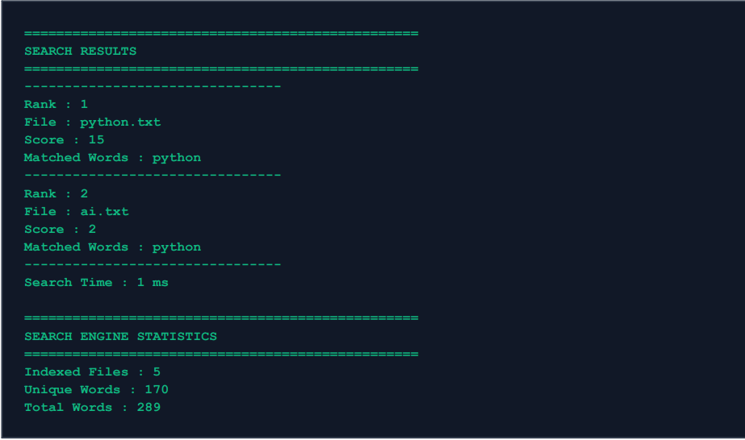
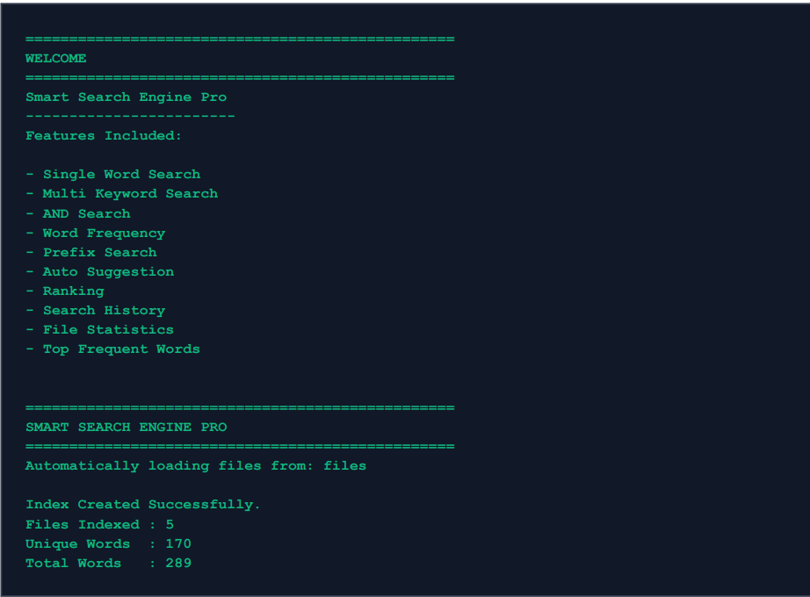

Example of auto suggestion system
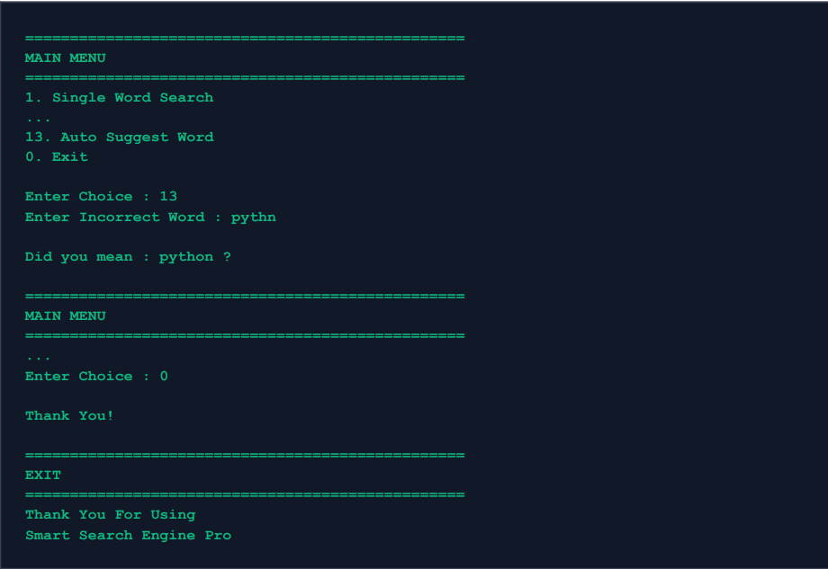

CONCLUSION
The Smart Search Engine Pro Using Java is a successful example of the practical implementation of an efficient and intelligent information retrieval system, capable of searching and managing different text documents in a fast and accurate manner. The application can reduce the search time drastically as compared to the traditional sequential file searching method, and it also guarantees reliability as well as relevant search results by implementing the Inverted Index technique and the Java Collection Framework. The use of a modular architecture greatly facilitates the coding, testing and upgrading of the system, improving its maintainability, scalability and flexibility. It integrates all the necessary functions, including single-keyword search, multi-keyword search (AND/OR), frequency-based document ranking, intelligent keyword suggestions, managing search history, and document statistics, resulting in a comprehensive and intuitive searching experience for the user. The use of Object-Oriented Programming (OOP) principles and the efficient data structures used, like HashMap, ArrayList, Set, and Queue, further enhance the overall system performance and reliability. The project not only achieves its goal of creating a quick and effective local document search engine but also offers valuable hands-on experience with software engineering, data structures, algorithms, and information retrieval concepts. Additionally, the implemented system proves to be highly flexible for future improvements such as implementing a GUI, indexing PDF and Word documents, integration with cloud, interfacing with databases, semantic search, and implementing AI-based search mechanisms meeting the requirements of new technologies and real-world information management systems.

FUTURE WORK

Smart Search Engine Pro Using Java offers a solid basis for creating more sophisticated and intelligent search engines. The application could be improved to allow users to search through other document formats like PDF, Microsoft Word, Excel, and PowerPoint in the future. It is possible to incorporate a Graphical User Interface (GUI) for enhancing usability and user interaction. The system can also be integrated with Artificial Intelligence (AI) and Natural Language Processing (NLP) to grasp the intent behind user queries, conduct semantic searches, and provide context-relevant results rather than just keyword matches. In addition, adding cloud storage, database integration, real-time document synchronization, voice search, multi-lingual document indexing, and machine learning based personalized ranking would make the application a modern, scalable and enterprise level search engine to serve future information retrieval needs.

REFERENCES
- Herbert Schildt, Java: The Complete Reference, 12th Edition. New York, NY, USA: McGraw-Hill Education, 2021.Node.js Documentation
Available at: nodejs.org/docs/latest/api/
- C. D. Manning, P. Raghavan, and H. Schütze, Introduction to Information Retrieval. Cambridge, U.K.: Cambridge University Press, 2008.Leaflet Documentation. Available at: leafletjs.com/
- H. M. Deitel and P. J. Deitel, Java: How to Program, 11th Edition. Boston, MA, USA: Pearson Education, 2018.Mozilla Developer Network (MDN) Web Docs Available at: https://developer.mozilla.org/
- Oracle Corporation, Java Platform, Standard Edition (Java SE) Documentation. Available at: https://docs.oracle.com/en/java/HTML
And CSS Documentation (MDN).
Available at: https://developer.mozilla.org/en-US/docs/Learn
- Apache Software Foundation, Apache Lucene Documentation. Available at: https://lucene.apache.org/ (Accessed: July 2026).
Vercel Documentation. Available at: https://vercel.com/docs
- R. Sedgewick and K. Wayne, Algorithms, 4th Edition. Boston, MA, USA: Addison-Wesley Professional, 2011.

